# Homework 4 – DC Machines

*This homework is to be solved using computational tools (such as MATLAB). A template is provided. You should submit your homework by converting your .m file solution (from the template) to pdf by using publish command. Required explanations and several tips are given in the template. Please, delete unnecessary details in template.*

## Q.1.

### Part A:

A 29kW, 440V, permanent magnet excited DC motor operates at 1000 rpm on full load. The motor efficiency is 86.72 %, and armature resistance is 0.337 ohm. (The motor is operating at steady state and the circuit schematic is illustrated in Figure 1.) The frıction loss is 1 kW.

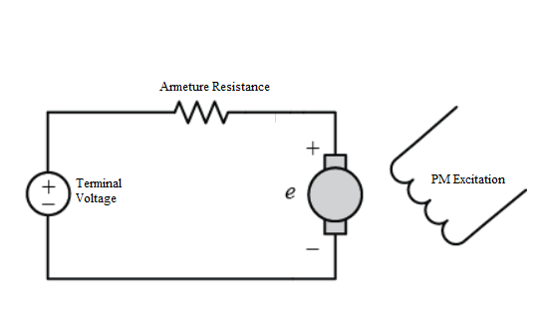

Figure 1 Simplified Circuit of PM DC Motor

1. Find the mechanical output power of the motor.
2. Find the mechanical torque of the motor.
3. Find the electrical power input of the motor.
4. Find the armature loss of the motor.
5. Find the armature current of the motor.
6. Find the induced EMF of the motor.
7. What do you suggest to control speed of the motor? Please, comment each suggestion properly.

### Part B:

The setup in Figure 2 that is called Ward-Leonard System is established control the speed of DC motor in Part A. In short, DC motor is driven by the DC generator and the DC generator is rotated by a 3-phase AC motor.

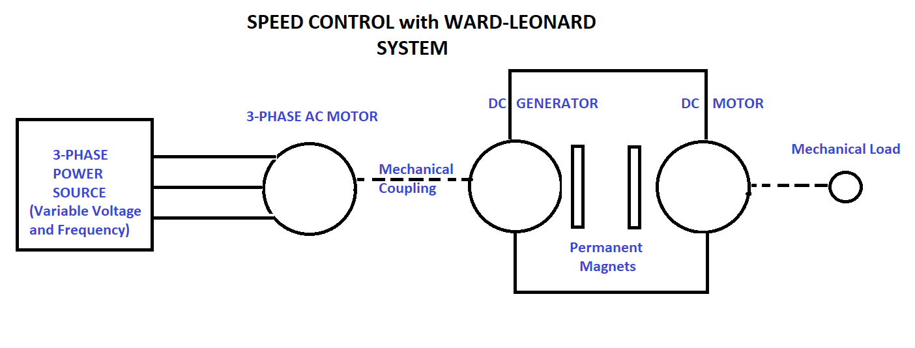

Figure 2 Ward-Leonard System

For the DC generator, armature resistance is 0.336 ohm. Assume that both motor and generator are operating in linear region (induced voltage $E_{a}$ linearly changes with speed), and rotational loss is constant. The Figure 3 shows circuit diagram of the DC motor and the generator.

1. For DC motor operating as in Part A, determine the induced EMF of the generator at full load.
2. Determine the no-load speed of the motor. Hint: Both machines are PM excited, so that field excitation is constant and as given above both machines operate at linear region.

Now, we would like to have a variable speed system. To achieve that we replace the DC generator with a separately excited DC generator. So that we can also control the field. The new generator has the same characteristics as the previous one.

1. We want to obtain no-load speed of 1025 rpm, calculate the reduction in field current in percentage compared to the rated operating point in Part A.
2. What must be the induced EMF in the generator if the motor supplies the same torque as in Part A but at speed of 750 rpm?
3. To operate at the operating point above, what is the percent change in the field current of the generator?

## Q.2.

The reluctance motor is a synchronous motor whose reluctance changes as a function of angular displacement θ between the rotor and stator. The motor does not have field winding on the rotor, and single phase 2-pole reluctance motor is illustrated in Figure 4.

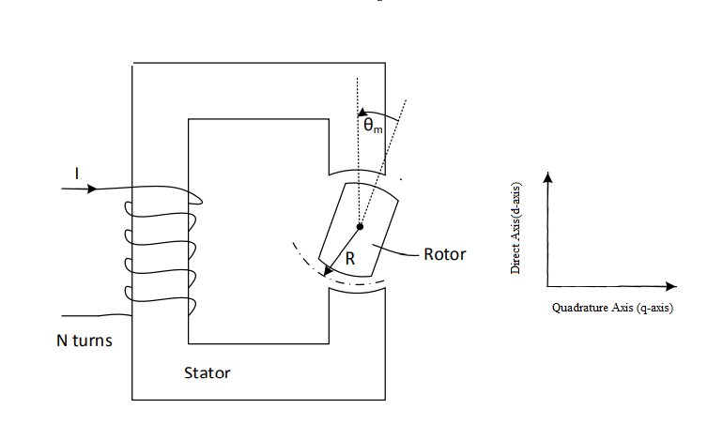

Figure 3 Single-Phase 2-Pole Reluctance Motor

When $θ_{m}$ is zero, the effective air gap is minimum. So, reluctance is minimum and inductance is maximum. This inductance is called $L_{d}$.

When $θ_{m}$ is 90 degrees, the effective air gap is maximum. So, reluctance is maximum and inductance is minimum. This inductance is called $L_{q}$.

Assume that A is area per pole and A is constant at every rotor position. Core materials have an infinite permeability $μ→∞$.

$L(θ_{m}) = 0.5(L_{d}+L_{q}) +0.5(L_{d}-L_{q})cos(2θ_{m})$ (1)

Eqn. 1 shows the change in inductance with respect to angular position $θ_{m}$. The stator winding has 100 turns in total (N=100) and excited by 2 A.

1. When $θ_{m}$ is zero, effective air gap is 1 mm and A= 10 cm2. Calculate reluctance and inductance ($L_{d}$) at this position.
2. When $θ_{m}$ is 90 degrees, effective air gap is 10 mm and A=10 cm2. Calculate reluctance and inductance ($L_{q}$) at this position.
3. Plot inductance of the motor with respect to angular position $θ_{m}$ using 1.
4. Plot electrical torque of the motor with respect to angular position $θ_{m}$.
5. Assume that the initial position of the motor is $θ_{0}=π/6$ rad and mechanical speed $ω_{m}$ =377 rad/sec. Plot electrical torque as a function of time. ( $θ_{m}$ = $ω_{m}t+π/6$). What is the average torque?
6. If the excitation current is alternative current in the form $i\left(t\right)=I_{max} sin(ω_{e}t).$ Can we get a net positive output torque? Explain the conditions by commenting on the effect of source angular frequency $ω_{e}$, mechanical angular frequency $ω_{m}$ and initial position $θ_{0}$ on average torque.